# Storyline

* **Outline of the main plot points of the game.**
  + It is just to encourage exploration.
  + You go to a mazing park but when you enter, the entrance disappears so you have to find your way out but find that you may need to get the item to help you get through. The Item(s) haven’t been decided yet, but I should be able to say in the full GDD.

# Levels

* **List of all the levels and explanation of how each level flows in each other.**
  + The plan is for each type of wall/fence means a new area, but you can backtrack to the prier area if there is something you missed there.
    - The known areas at this point is:
      * a wooden fencing area (possibly having a few types of wooden fencing which are different areas)
      * a stone wall area (possibly having a few types of stone walls which are different areas)
      * metal fencing area
      * plant walls area (Bush/hedge)
  + I want to encourage exploration.
* **Graphs outlining how the game progresses as the player plays.**

This is not the end graph because it may change throughout the development.

# Character Art

* **Character art and bios.**
  + You don’t really get to see the player character.
  + The player character is supposed to represent the player, so I don’t really want to make the player see their character except for a minimum of their hands and maximum their forearms so there can be some emersion.
  + At this point, there will be no enemies.

# Environment ideas

* Possibly an old theme park environment. (can’t really provide images because I can’t find ones that I like so I most probably will make my own)
* The maze walls are stone walls, wood fencing, metal fencing (wire fencing), and plant bush(hedges). I have chosen this because I want it to be a mix of environmental feelings.
* In a way, it is like the backrooms, but I don’t want it to be like that as much as I can at least.

# Environmental Art

* Environmental art to be used in production.
  + Some of the textures here <https://github.com/Stampard0/Textures> (mainly what is in the Fence & Walls for Maze file and the Terrain file).
  + Here are some examples

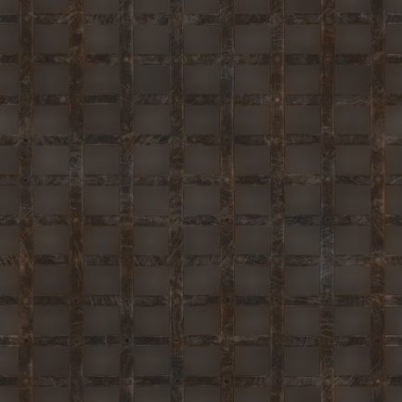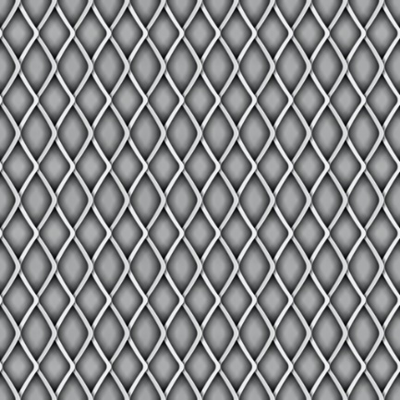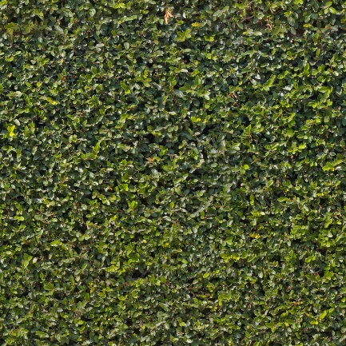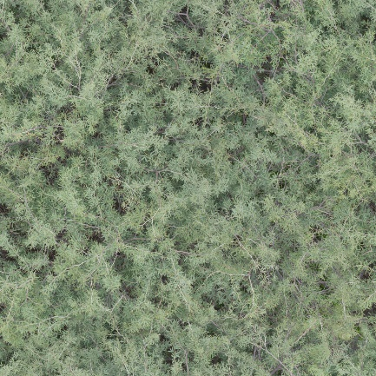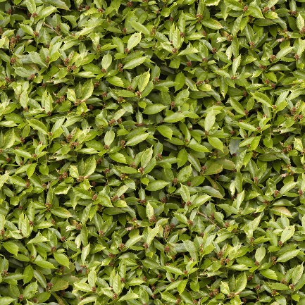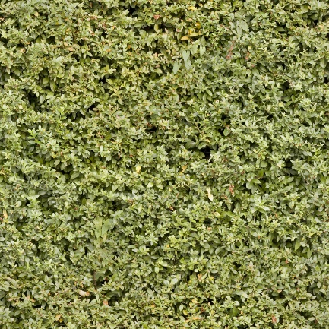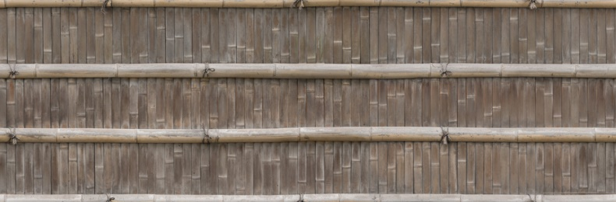

all of these are downloaded from <https://www.textures.com/library>

# GUI

* **Splash screens**

Looking over the amusement part, looking at the amusement park or looking at the entrance to the maze

Exit/Close

Options

Continue]

Start/New_Game

Planning on the photo being a little look of the maze but not showing the maze path. Possibly a panorama (camera is turning around) & possibly have the name of the game somewhere (maybe moving to a different spot depending on what photo)

Loading Bar

* **Main Menu**

Selecting the Start/New_Game or Continue button the camera moves into the entrance of the maze. (With a little spin)

For the Start/New_Game button if you already have a save then it will ask if you want to over right your previse save. If you do, then it will move the camera into the entrance & if you don’t then it won’t do that.

For the Continue button, it will move the camera into the entrance with a bit of a faster spin.

* + **HUD**

Hotbar

It is a very simple HUD

# Sound and music

* **What music and sound will the game need?**
  + The game would need some eerie sounds. (Like some footstep sounds (that aren’t the players) & some generic eerie sounds.)
  + Not sure what music if any at this point.
* **How will you use audio to enhance the player experience?**
  + I will use the audio to enhance the feeling of uncertainty.